**ISEM 3006 Data Management in Business**

**Individual Assignment**

**(5% of Total Marks)**

**Deadline: 5 December 2020 (11:59pm)**

**Chiu pit ho 17212049 section1**

**Question 1**

**Use the Trustful Property Rental Company Database in Exercise 3.**

**Use PostgreSQL SELECT statement to answer the following queries.**

**Unless state otherwise, the case of strings is important, i.e. if I ask you to retrieve properties that are located in 'KLN', you only retrieve properties that are located in 'KLN', but not 'kln', 'Kln', 'kLn', etc.**

1. For the three properties that have the most viewings, list the property number and property street. There may be tie, i.e., if the fourth property is having the same number of viewings as the third one, you should also list the third property. (15 points)

SELECT P.PropertyNo , P.propertystreet , COUNT(V.ViewingNo) AS "Number of Viewings"

FROM Viewing V JOIN Property P

ON P.PropertyNo = V.PropertyNo

GROUP BY P.PropertyNo, P.PropertyStreet

HAVING COUNT(V.ViewingNo)

IN

(SELECT COUNT(ViewingNo)

FROM Viewing

GROUP BY PropertyNo

ORDER BY COUNT(ViewingNo) DESC

FETCH FIRST 3 ROW ONLY)

ORDER BY COUNT(ViewingNo) DESC;

1. Explain your logic. (5 points)

First i make a subquery to find out the top three amount of Number of Viewings

(SELECT COUNT(ViewingNo)

FROM Viewing

GROUP BY PropertyNo

ORDER BY COUNT(ViewingNo) DESC

FETCH FIRST 3 ROW ONLY)

Then i join the Viewing and Property table, using GROUP BY , count the Number of Viewings for all Property

SELECT P.PropertyNo , P.propertystreet , COUNT(V.ViewingNo) AS "Number of Viewings"

FROM Viewing V JOIN Property P

ON P.PropertyNo = V.PropertyNo

GROUP BY P.PropertyNo, P.PropertyStreet

Finally, I use HAVING to find out which Property’s Number of Viewings is in the subquery, then ORDER it, return the P.PropertyNo , P.propertystreet .

**Question 2 (30 points)**

You are one of the organizer of a poster exhibition on Global Issues and you must design a database to keep track of the administration of the exhibition.

Graphic designers create posters for the exhibition to illustrate one of the chosen global problems. Relevant information on designers includes their name, phone number, email address, and the name of the organizations they work for. A unique designer code will be given to the designer when he or she submits the first poster. The submitted poster must has a title and is assigned an identification number. A poster may be created by several graphic designers. The percentage of the contribution of each designer in creating the poster needs to be recorded. Each individual designer may be involved in at most 5 posters. Where a group of graphic designers create a poster, a designer needs to be designated as the contact person. This information needs to be recorded. A poster may receive an award from the organizer. There are different awards. There may be multiple posters that can receive the same award. However, one poster can only have one award. Each award is identified by an award name. Other information includes the amount of the prize and the maximum number of posters that can receive the award.

Construct an entity-relationship model according to the above description Add any entity types or attributes that are required to support the operations. **Resolve the many-to-many relationships**. List the attributes with the entity type, underline the primary key, and **put the foreign keys into the proper entity type** so that the entity types can be converted to relational tables directly. Be sure to state any **reasonable and necessary** assumptions that you have made

|  |  |  |  |
| --- | --- | --- | --- |
| **designer**  designer_no (PK)  designer_name  designer_ph_no  designer_email  designer_org | **poster**  poster_id (PK)  poster_title  poster_con_per  award_name (FK1) | **design**  designer_no (FK1)  poster_id (FK2)  poster_contribution | **award**  award_name  award_prize  award_max_num |
|  |  |  |  |

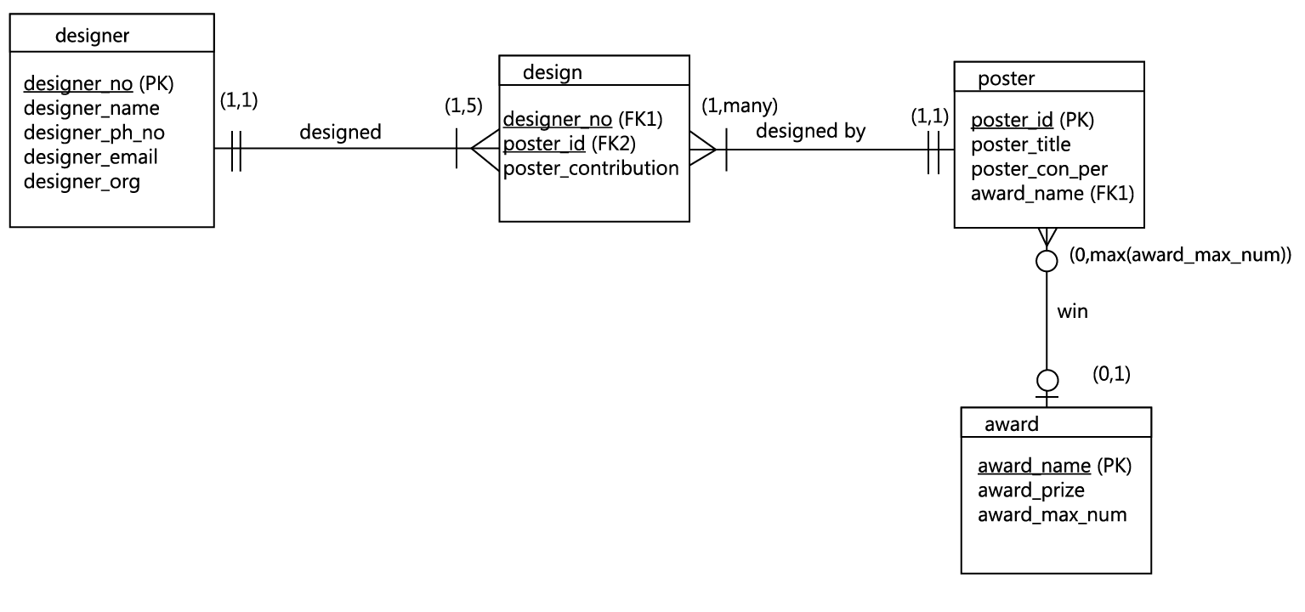

Assumption:

~ Every input of designer should also input at least one poster record

~ Exist posters that will not have awards, also exist awards that will have no winner.